# **CSU11013 – Programming Project 2021**

**Group 28:**

**Group Members:**

* Karthik Venkatesh Nagaraj
* Niall Connolly
* Victoria Emukperuo
* Jhellen Kyle Daniel Agsalud

**Introduction:**

Our initial aim of the project was to create a functional program that read in data from a CSV file which would then display the data through different graphs. It would also have user input queries to filter the data shown on the graph.

**Organisation:**

During our first meeting we brainstormed ideas such as an interactive map, which would allow you to click on any state and bring you to another page which has information about the Covid-19 cases in that state. After, we decided on how we were going to split up the work as a group. We decided that Karthik would handle the data, to read in the data from the CSV file and to create graphs. Niall would work on the widgets/buttons e.g., an exit, back and search button and creating multiple screens. Victoria would work on making the actual program visual pleasing and Kyle would help the others with their own task to lighten their workload.

**Outline:**

At completion of our program, we ended up with seven classes on top of our main class.



The basis of our program is an interactive map that allows you to click on a state to find information on Covid-19 for that selected state.

The first screen of the program shows the map and three other buttons/widgets, a “Search”, “Quit” and “US Graph” button. The “Search” button allows you to search up a state instead of using the map, the “Quit” button ends the program and the “US Graph” button brings you to another screen, where a graph of the number of cases for each state is shown.

When a state is clicked on or searched up the user, another screen is displayed, which shows information for Covid-19 in that state, i.e., the total number of cases for the time period, 21/01/2020 – 28/04/2020, the largest number of cases in one day and the date it occurred. Furthermore, we have another “Search” button that allows the user to search up a specific area in a state. For example, “Snohomish” in the state of “Washington”. The user also has the selection of checking the number of cases for the first 30, 60 and 90 days since Covid was detected in that state.

**Features:**

One of the main features of our code is our ***INTERACTIVE MAP***, a map with clickable buttons that brings you to another screen that contains information on the state clicked.

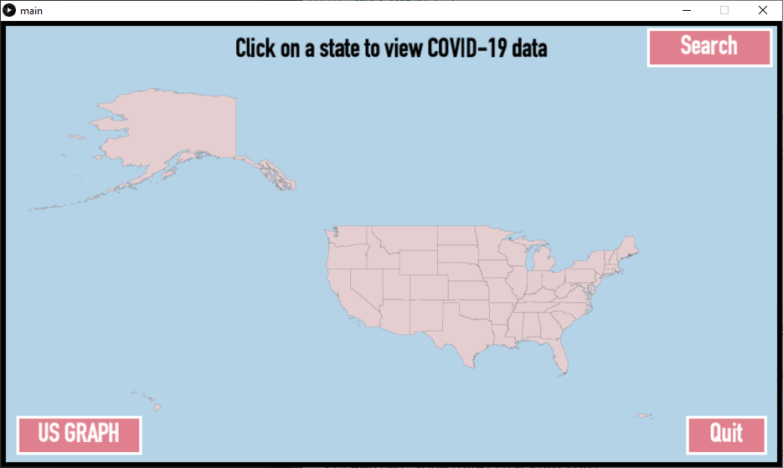

Another feature is our ***US GRAPH***, a graph that shows the number of cases for each state.

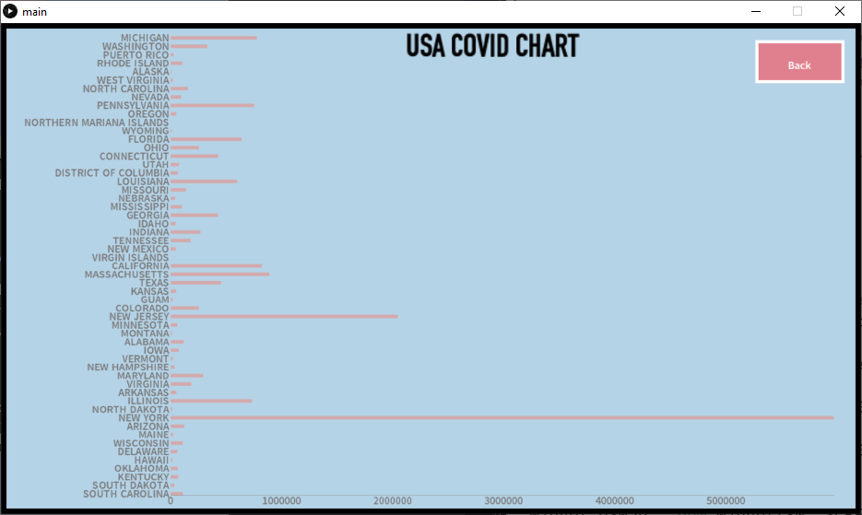

A ***SEARCH BAR*** feature, that allows you to search up a state instead of choosing one from the interactive map.

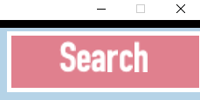

Lastly, an ***INFORMATION PAGE***, where you can see general information about a state, find the number of cases for a specific area in that state, using a search bar, and find the number of cases for the first 30, 60 and 90 days.

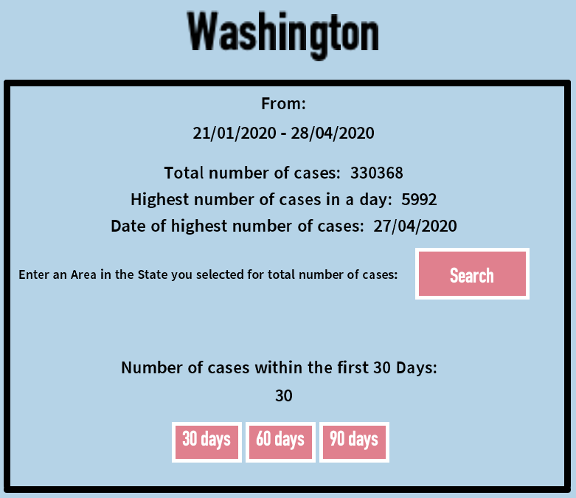

**Problems Encountered:**

One of the biggest problems we have encountered was creating a graph, initially we wanted multiple graphs however we struggled on going about it, we tried different libraries such as “giCentre Utils” or “Grafica” and even tried coding it from scratch. However, thanks to Karthik who figured out how to use the library “giCentre” we managed to have some visual representation of the data.

Other problems were small issues, mainly trying to debug our code.

**Personal Experiences:**

**Karthik Venkatesh Nagaraj:**

Since this was my first time ever working on a group-collaborative project of this size, I was extremely overwhelmed in the beginning. But eventually I managed to get the hang of it and took some leadership responsibilities apart from my general coding responsibilities to make sure we reached all our weekly goals, and everyone was satisfied with the code that we were committing into the SVN. In the project itself, during the first week it was my responsibility to come up with a solution that would help us read data from the CSV file efficiently which was then done with the help of tables. In the next few weeks, I did a lot of research on what would be the best way to have a map displayed on screen. After a while I found out about a library called geoMap that helped us do exactly what we wanted. The documentation for the library was pretty simple and clear enough for me to be able to implement a fully interactive map where the user could hover over a state and be able to click on it to see COVID data and information related to that state. After some very unsuccessful attempts at creating a graph that displayed the data a little clearer, I finally was able to create a graph which displayed the number of cases for each state. This graph was done using the giCentre library. Finally, along with the help of Niall, I made the search bar in the main screen which can be used to go to a state’s screen just by typing the state’s name. It was made in such a way that if the user types in a state that does not exist, it displays an error message in the console. This project has helped me learn so much extra stuff through all the research that was done. Overall, this project has helped me understand a little more how big software companies get work done and has made me look forward to future group projects as this.

**Niall Connolly:**

I enjoyed doing this project because it gave me good insight on how programs are developed in a professional setting. My responsibilities for this project revolved around using the widget class from a previous assignment to create the buttons and search bars for each aspect of the project. I created a Widgets class and a textWidget class and helped other members of the group to connect and use these widgets for their sections of the project. I was in charge of making our US map clickable so that it would go to a separate screen specific to the state clicked on. I was also in charge of creating a Screen class which was used to determine what widgets were showing on each screen. Lastly, I helped design what we wanted the visual aspects of the program to look like while we were in the early stages of the project. I often worked with Karthik to help implement the user queries required for the project. I learned a lot throughout this project, I learned about team dynamics for software projects, and I learned about how cooperation can make these sorts of projects much easier. I hope to be able to use the knowledge and experience gained during this module in my future endeavours.

**Victoria Emukperuo:**

Reading the brief of the project made me extremely anxious, it was so open ended, and you could go so many ways with it and it’s one of the biggest projects I’ve done to date. Straight away, I knew I would like to work on front end because I like designing things. Once we got our weekly goals and gave everyone a role and what to work on, we started. During the first week, I decided what the colour scheme would be, chose a map to be our interactive interface and worked on the layout. I helped look for ways to implement a graph into our project and made a few attempts myself. Karthik finally found a library that did exactly what we needed it to. I gave suggestions to the group that were later utilized (e.g., clearing search bar after user clicks). Once most of the code work was done, I did the last and final re-design over the entire thing and we were very satisfied with it. This project has taught me so many new pieces of code, libraries and how to work with other programmers in a group.

**Jhellen Kyle Daniel Agsalud:**

This was my first time working as a group for a coding project. I think one of my initial thoughts was me being scared that I would let down my team because I am someone who didn’t have previous experience and wasn’t the best at coding. However, working with the group was honestly fun, creating a program together that is something I think we are all very proud of, was such a great experience. My initial role was to help everyone with their own individual task. But as the weeks progressed, my main role was to get information on COVID-19 for a specific state. I created an “Info” class, which got general information such as the total number of cases for a state. I also coded it so that it gets the number of cases for the first 30, 60 and 90 days since the first entry of that state and have another part which gathers the number of cases for a specific area based on what the user entered. I struggled on making the widgets myself but thanks to Niall and Karthik we have a “Search” button for user input and a specific area and widgets for choosing how many days the user wanted to check. On top of this, towards the end of our project I was also tasked with writing up the main report. Overall, this was a great experience, and I am really happy with the outcome.